Title of the Thesis

Master Thesis

Author Name

Supervisor:
Prof. Dr. Michael Felderer
Department of Computer Science
Universität Innsbruck

Innsbruck, 01.01.2019

Abstract
Provide a short summary here

Keywords:

Table of Contents
Abstract 2
Table of Contents i
1 Introduction 1
1.1 Problem statement 1
1.1.1 The Concept of … 1
References 2

Introduction
The aim of this thesis is to investigate ...

Problem statement
The problem is … reference [2]

The Concept of …
This section outlines …
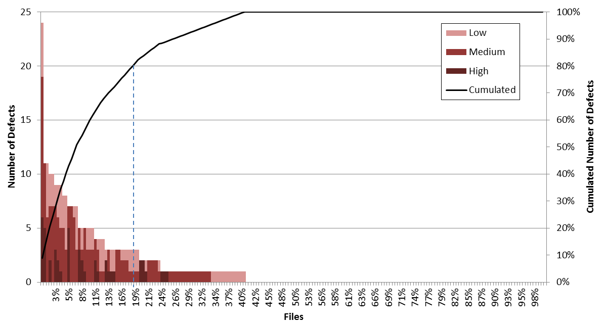
Figure 1. This figure

References

[1] | M. Felderer and I. Schieferdecker, "A taxonomy of risk-based testing," International Journal on Software Tools for Technology Transfer, no. Volume 16, Issue 5, pp. 559-568, October 2014.
[2] | ISO/IEC 25010:2011, "Systems and software engineering -- Systems and software Quality Requirements and Evaluation (SQuaRE) -- System and software quality models," 2011.
[3] | M. Felderer, C. Haisjackl, V. Pekar and R. Breu, "An Exploratory Study on Risk Estimation in Risk-Based Testing Approaches," Software Quality. Software and Systems Quality in Distributed and Mobile Environments. 7th International Conference, SWQD 2015, Vienna, Austria, January 20-23, 2015, Proceedings, LNBIP 200, pp. 32-43, January 2015.

